A000-Asia-China-Liangzhu-Cong-Eight Tier-Jade-ca 2250 BCE

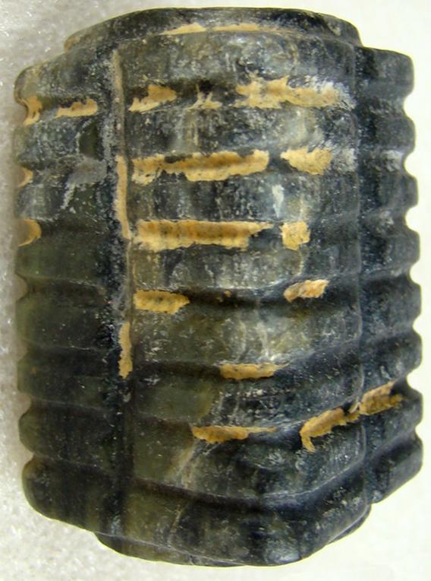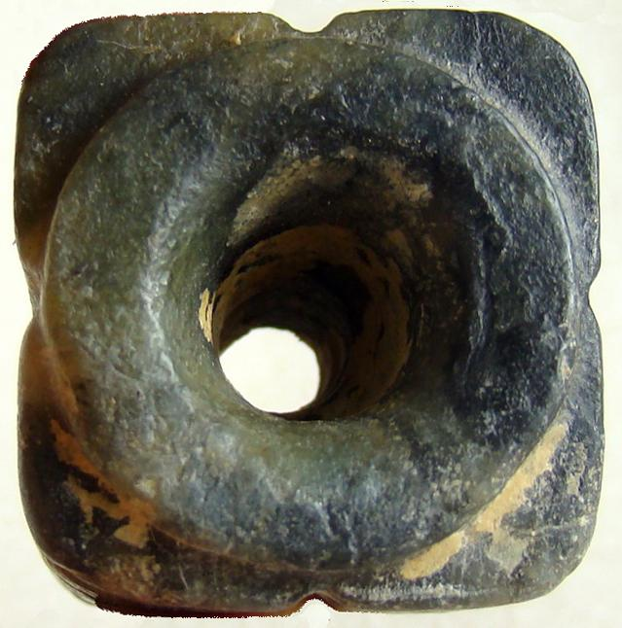

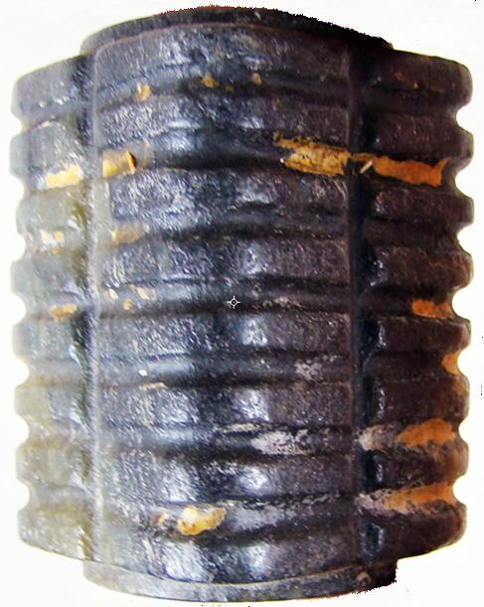 SHAPE \* MERGEFORMAT 

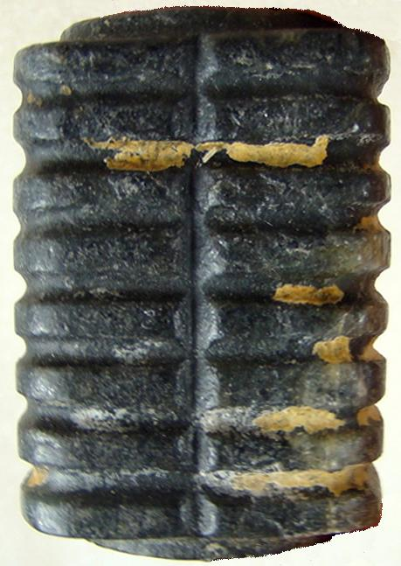

Figs. 1-5.

Case no.:

Accession Number:

Formal Label: Liangzhu-Cong-Eight Tier-Jade- ca 2250 BCE

**Display Description:**

This congisin the color of blackened Earth. As congs became more elongated the original paring of animal and anthropomorphic masks became obliterated, with only the human mask surviving as in this example. **At the end point of this trend the mask became mere ridges that no longer had even an abstract likeness to a human mask.** Finally, the cong was no longer made of jade the divine substance but of wood. Its secularization was complete.

The evolution of the cong mask, therefore, appears to have undergone a transformation from that of a shamanic device of invoking animal powers to that of purely human ancestral powers by eliminating the animal panels to that of a series of purely abstract ridges suggesting a semiological transformation as well: from symbolizing the numinous power of shamanic elders to symbolizing the historical succession of generations purely abstractly.

The cylindrical tube represents both the birthing canal through which all life emanates and correlatively the pit into which sacrificial victims are offered (Li-Ki 20 [Tsi-fah] from Couvreur, Liki II, 259). Opposing masks of the cubic faces represent Mother Earth and the Son of the Sun, probably an anthropomorphic ancestral figure associated with fructifying soil. On the other two opposing faces are cloud motifs.

Liangzhu Congs are comprised of a square or nearly square exterior prism enclosing a circular inner column. The square represents Earth and the circular column represents Heaven. The color of the cong also hints at this symbolism. The late Zhou ritual classic, *Zhou Li* p, *Chou Li*  wg(周禮) in the middle of the 2nd century BCE, compiled some three thousand years after the present example was manufactured, stipulated that "jade is used to make the six instruments by which the king worships Heaven and Earth and the four quarters [Spring, Summer, Autumn, Winter]. By the green *bi* (p), *pi* (wg) [round jade disk], heaven is worshipped; by the yellow cong (wg), tsung (p), Earth [is worshipped]" (Biot 1851). This cong may have been once more yellow, and its present creamy off-white color is thought to have been produced by minerals leaching from the decaying body into the nephrite during burial, a process that occurs in the first weeks after interment.

According to Hayashi Minao, a Japanese expert of Liangzhu jades, two-tier congs are the earliest and were produced in the early Liangzhu period, ca. 3200 BCE, based on archaeologically excavated examples (Hayashi 1973; Hayashi 1990:6). In later Liangzhu phases such as in this example, congs were elongated with multiple tiers. In the early Liangzhu period the central hole was characteristically wide and as the congs were elongated the central holes, generally, were narrowed.

The square exterior is comprised of single, repeated cartouche-like panels on each of the four corners representing an anthropomorphic mask suggesting a shamanic trance. This iconography undoubtedly harkens back to a pre-Neolithic period when shamanic imagery was the symbolism of hunter-gatherers and was the imagery that was inscribed on petroglyph panels. Indeed, Hayashi Minao argues that the name of the cong/tsung derived from zhu/chu meaning "master" which we expand to "master of animal powers" (Hayashi 1990:6).

The interior of the column was believed to be the conduit for the communication with the numinous spirits that were depicted on its external surface.

**LC Classification:** NK5750.2.A1

Date or Time Horizon: Liangzhu culture, lower Yangzi River Valley, 3300-2250 BCE

Geographical Area: Liangzhu culture, lower Yangzi River Valley

**Map:**

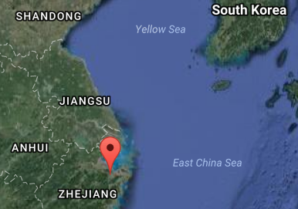

Fig. 6. Location of Liangzhu site proper.Source: Google Earth

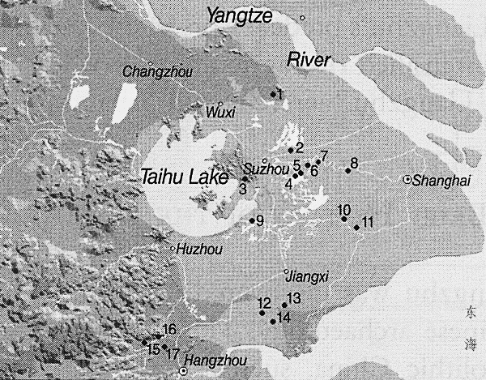

Fig. 7. Detail of Liangzhu site complex surrounding Taihu. After Zhou Ying 2007.

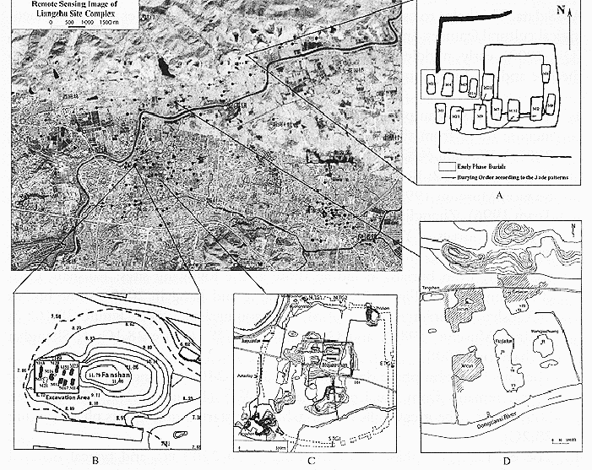

**Fig. 8.** Detail of Liangzhu site proper. After Zhou Ying 2007.

**GPS coordinates:**

Northeast corner: N 30°24'48", E 120°00'17"

Northwest corner: N 30°24'41", E 119°58'58"

Southeast corner: N 30°23'20", E 120 00'19"

Southwest corner: N 30°22'55", E 119°58'28"

Cultural Affiliation: Liangzhu

Medium: jade

Dimensions: H 1.8 in., W 1.2 x1.2 in

Weight: 112 gm

Condition: original

Provenance:

**Discussion:**

Liangzhu (3400–2250 BCE) in Yuhang County, Zhejiang, was a highly stratified Neolithic jade city-state in the Yangtze River delta where élites controlled a sphere of influence north to Shanxi and south to Guangdong.

DNA recovered from Liangzhu graves shows high frequencies of Haplogroup O1 linking it with modern Austronesians.

The use of jade and other expensive wares (such as silk, lacquerware, and ivory) in grave sites characterized the social symbolism of Liangzhu élites. About 4200 BP Liangzhu succumbed to a series extreme floods since the cultural layers are interrupted by intrusions of mud and sand. It is also possible that an asteroid created Taihu lake 4500 BP, which contributed to its demise.

**References:**

Chang, K.C., Xu, P. and Lu, L. 2005. *The formation of Chinese civilization: an archaeological perspective*. New Haven: Yale University Press.

Li, Hui; Huang, Ying; Mustavich, Laura F.; Zhang, Fan; Tan, Jing-Ze; Wang, ling-E; Qian, Ji; Gao, Meng-He; Jin, Li. 2007. "Y chromosomes of prehistoric people along the Yangtze River," Human Genetics **122**: 383–388.

Wu, Li. 2014. "Holocene environmental change and its impacts on human settlement in the Shanghai Area, East China," Catena. **114**: 78–89

Zhang, Chia; Hsiao-Chun, Hung. 2008. "The Neolithic of Southern China–Origin, Development, and Dispersal,"Asian Perspectives. **47**:2, 309–310.

Zhou Ying. 2007. "The Dawn of the Oriental Civilization: Liangzhu site and Liangzhu culture. Beijing: China Intercontinental Press.